Project Reports

1 Intoduction

* 1. Overview

CRM for result tracking of a candidate project is an allotted one for us to give an any ideas and methods . the CRM means customer relationship management

* 1. purpose

CRM for Result Tracking of a Candidate project is useful for many school and college to make a simple solution for exam result. It make easy work for the result submission easily

1. Problem Definition & Design Thinking

Emphathy map

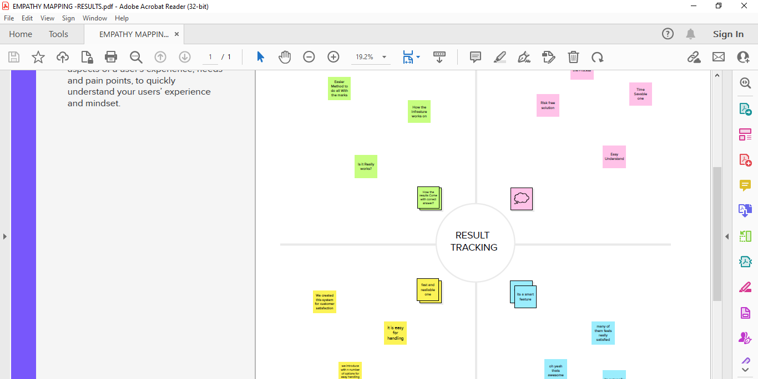

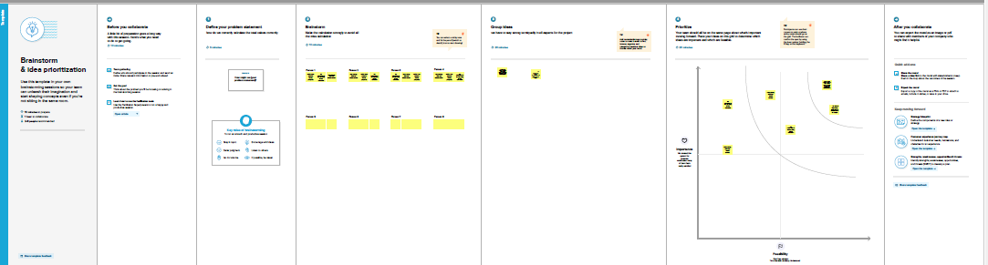2.2 Ideation & Brainstroming Map

RESULT

3.1 Data model

|  |  |
| --- | --- |
| OBJECT NAME | Field In The Object |
| SEMESTER | |  |  | | --- | --- | | Field label | Data Type | | Semester Name | TEXT | |  |  | |
| CANDIDATE | |  |  | | --- | --- | | Field label | Data Type | | Candidate Name | TEXT | |  |  | |

ACTIVITY & SCREENSHOT

4.1

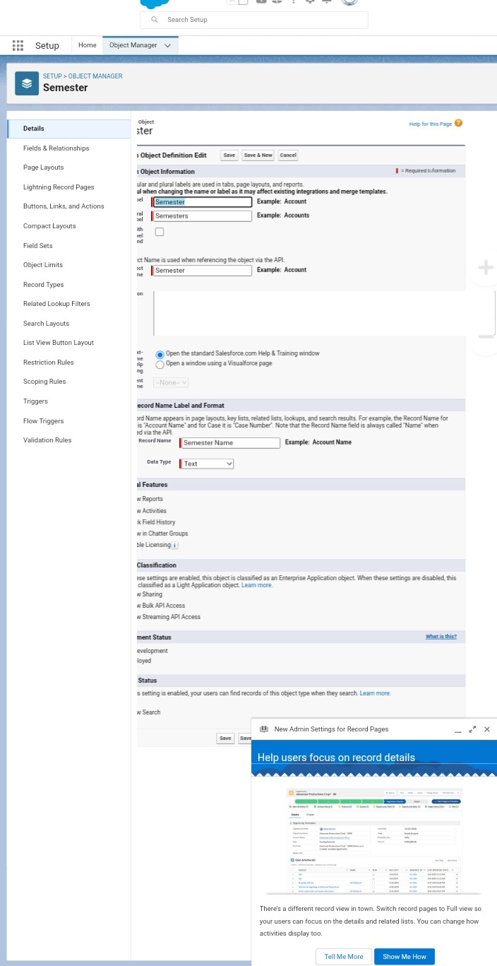

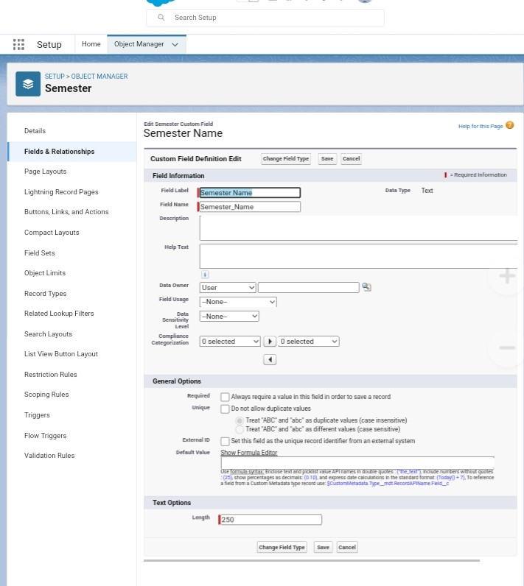

Trailhead Profile Public URL:

Team Lead : https://trailblazer.me/id/ingas4

Team Member 1 : https://trailblazer.me/id/hharan94

Team Member 2 : https://trailblazer.me/id/balap75

Team Member 3 : <https://trailblazer.me/id/gurup74>

5 . ADVANTAGES &DISADVANTAGES

1.Easy Handling for the Process

2.Time Savable one

NO disadvantages

6. APPLICATIONS

1.tracking customer

2.collecting data for market

3.improving interactions and communication

7. CONCLUSION

Customer Relationship management anables a company to align its stragey with the need of the customer in order to best meet those needs the ensure long term customer loyalty.

8.FUTURE SCOPE

This approach will be particular to companies operating in highly competitive markets where it is difficult to attract for new customer.